Design Review

Date: October 21, 2013

Author: Fanxing Meng

Reviewer(s): Jayaprakash Ganta

# Original Design

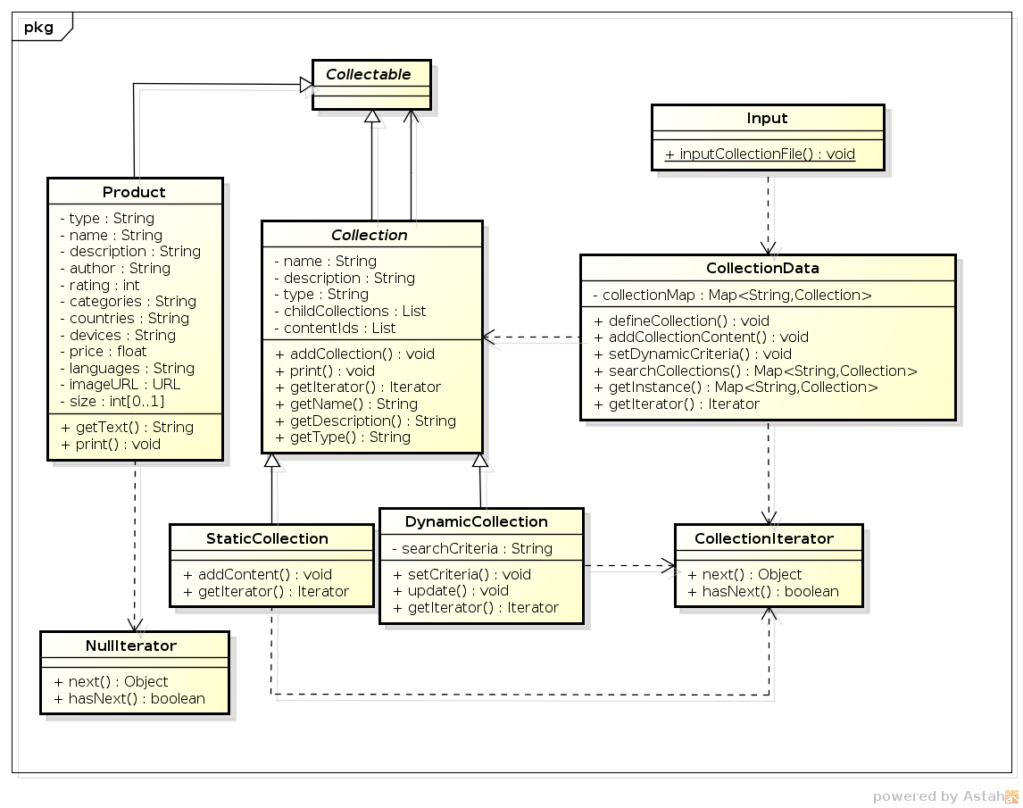

# Comments

Based on the early design, several flaws have been observed:

1. Since there are separate lists for product IDs and child collection IDs, we don’t need the null iterator to iterate through the collections and contents but instead treat the two subcategories differently.
2. Input class is redundant. Could just put the input method into the previous importer.
3. The arrows between collection and collectable is not entirely correct.
4. Factory pattern has not been incorporated.

# Changes

1. After trying to merge two separate iterators without using other packages in vain, I switched back to using the null iterator and collection iterator for one-go traversal. Keeping track of two different lists simultaneously does not seem to be accomplishable by current constraints. One drawback it brings is that now there is no fixed sequence between child collections and contents when traversing is in the same level; they are intervened.
2. Added a printCascade() method to all collectables, taking advantage of the universal iterator using stack-traversal. Calling printCascade() inside a collection automatically gets an iterator and traverses through the entire structure beneath this collection.
3. ImportCollectionFile() method is now in the common Importer class.
4. Content IDs don’t have to be available for both types of collections. Storing dynamically retrieved product IDs from query result is redundant and not needed. Instead, such temporary stage is now the allChild map, which gets populated upon traversing through querying or dereferencing.
5. Added factories for creating static and dynamic collections.

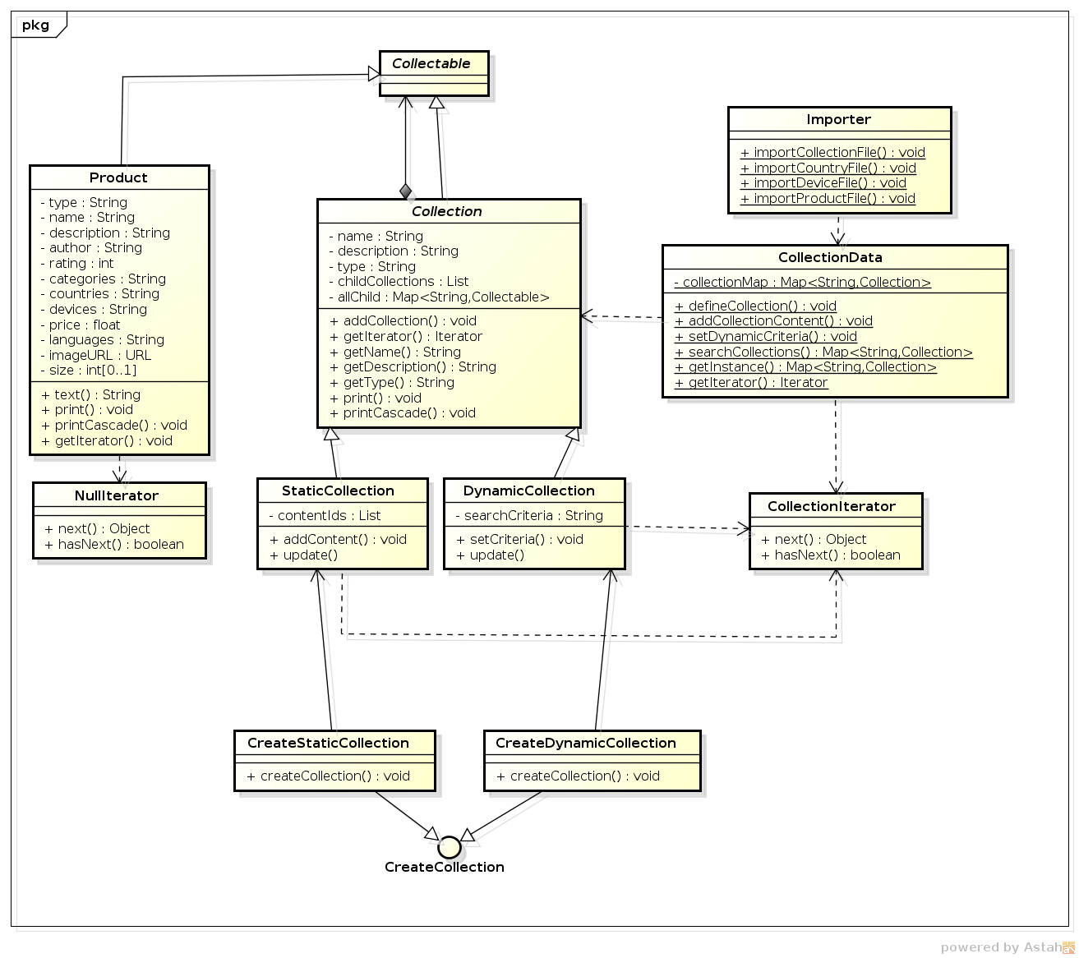

# Summary

The first version of the design document together with the review-amended one were capable of helping setting up a main framework. But many implementation difficulties and details forced further changes of the schema along the way.

The most tricky part in this design is perhaps due to the separate lists of child collections and list of product ID references. If allowing them to be put into one list, then there would likely be no need to invent the allChild map to merge the two groups of collectables.

The review process is partly useful in that it provided a chance to take notice of some severe mistakes at an early stage and forces critical reasoning before implementing it. It also helps practicing the ability to quickly look into other people’s logic and evaluate the strengths and weaknesses.